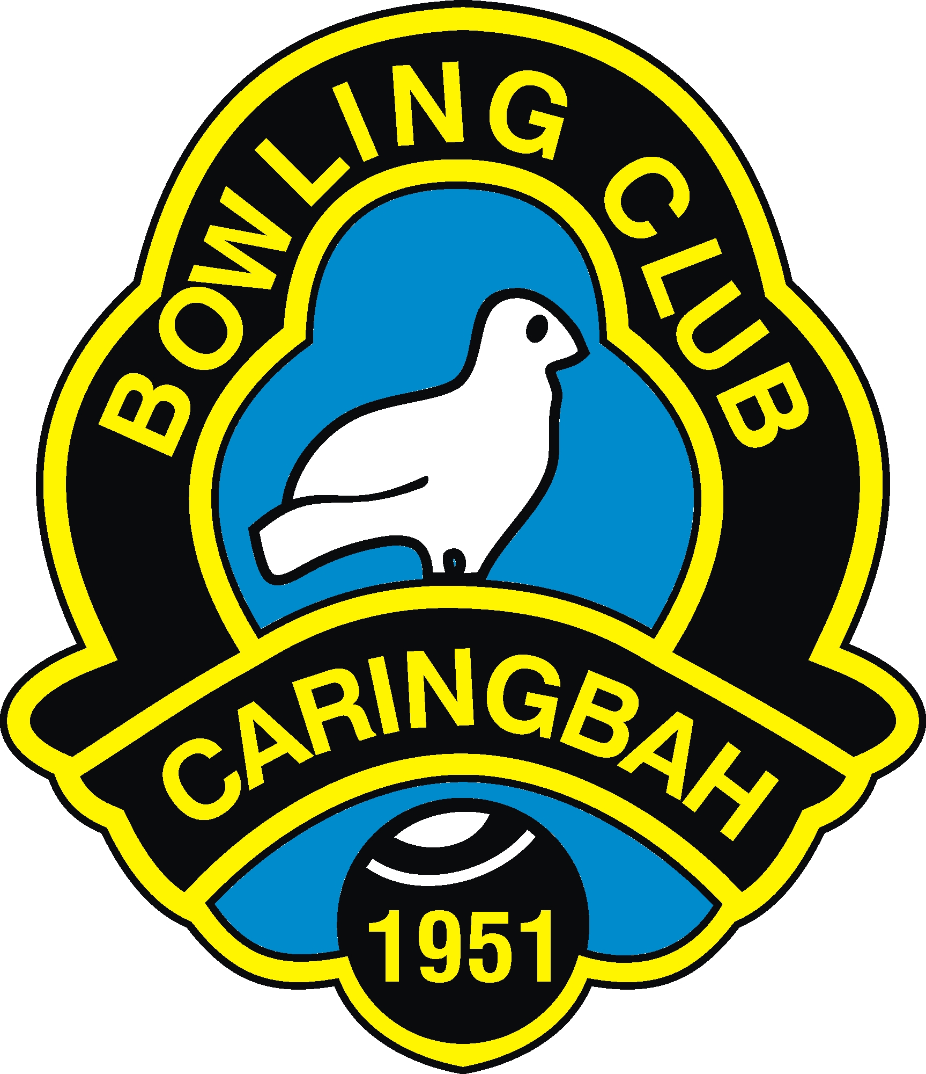 Caringbah Bowling and Recreation Club Limited
105 – 107 Willarong Road, Caringbah, NSW 2229
Phone: (02) 9524-7515 Fax: (02) 9540-5427
email: caringbah.bowls@bigpond.com

Hon. Chairman Barry Whitton Hon. Secretary Manager Garry Oldroyd
18th January, 2021
CLUB COVID-19 SAFETY PLAN
This plan is designed to address the safety and wellbeing of staff and patrons whilst on Club premises, things covered in the Plan may be used as a guideline for wellbeing or persons in their day to day lives.
- A notice is appended to the club entry indicating persons who feel unwell, including staff and patrons, should not enter the club premises but report to their doctor as a matter of urgency.
- To ensure the accuracy and timeliness of tracing persons with the possibility of either being infected or coming into to close contact with an infected person, all members and guests must sign in and out using the NSW Government QR code as well as the Club’s electronic sign in computer. Entry and exit records are kept electronically for later tracing reference.
- A number of hand sanizter dispensers are located throughout the club and all patrons are encouraged to use these frequently to cleanse their hands.
- Members and guests must maintain a minimum of 1.5 metres distance from each other, with the capacity of the club limited to 110 persons in total based on the clubs internal area.
- Staff are responsible to consistently wipe all areas and equipment with the club which are in regular, high frequency use with a sanitizing solution and cloths specific for this task.
- The senior staff member is to appoint an identified (Hi VIS) Covid Safety Marshall during busy periods and he/her will be responsible to maintain the requirements of this plan.
- Face masks are available for staff and patrons, staff must wear a mask when serving patrons. Everyone entering the club’s gaming areas must wear a mask, a personal fine of $200 for patrons refusing to wear a mask in these areas. They may also be asked to leave the gaming areas if they refuse to comply with this government requirement.
- Patrons are to utilise the floor social distancing marks when required to queue for service or to use facilities.
- Patrons are to be seated, maintaining physical distancing when eating or consuming alcohol, standing around socializing in the bar area or dance floor is not allowed.
- Dancing and singing indoors is not allowed at this time.
- Lawn Bowls equipment, jacks and mats, are to be regularly sanitized before and after use.
- Bowlers are to maintain correct social distancing where possible and use disposable cups for water on the greens.

All enquiries regarding this plan to:
Garry Oldroyd J.P. (NSW)
Hon. Secretary Manager/Licensee
(02) 95247515
0437004929

